Motion and Force in a Gravitational Field

Assignment Projectiles

Name: __________________________________________
- You throw a tennis ball into the air and catch it 2.80 s later. How high did you throw the ball?
(2 marks)
t total = 2.80 s s_{v} = u_{v}t + ½ gt²
t down = 1.40 s = 0 - 4.9t² [1 mark]
u_{v} top = 0 ms⁻¹ = -4.9 x 1.4²
g = -9.8 ms⁻¹ s_{v} = 9.60 m [1 mark]

- Kelsie throws a ball at the ground and it bounces upwards with an initial velocity of 4.70 ms⁻¹. The ball then goes vertically upwards to its highest point then returns and Kelsie catches it 0.850 m from the ground. With what velocity does it hit Kelsie’s hand? (2 marks)
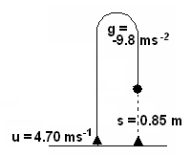
v_{v}² = u_{v}² + 2gs
= 4.70² + (2 x -9.8 x 0.85) [1 mark]
= 22.09 – 16.66
= 5.43
v_{v} = 2.33 ms⁻¹ downwards [1 mark]

- A rock is thrown horizontally out to sea from the top of a vertical cliff face with an initial velocity of 20.0 ms⁻¹. The rock was thrown from 44.1 m above the water.
  - How far from the base of the cliff did the rock hit the water? (2 marks)
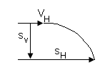
V_{H} = u_{H} = 20.0 ms⁻¹ s_{v} = u_{v}t + ½ gt² s_{H} = u_{H} x t
u_{v} = 0 ms⁻¹ -44.1 = 0 – 4.9t² = 20 x 3
g = -9.8 ms⁻¹ 44.1 = 4.9t²
s_{v} = -44.1 m t = 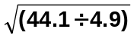 s_{H} = 60.0 m
t = 3.00 s [1 mark]
[1 mark]

  - What was the velocity of the rock just before it hit the water (include angle)? (4 marks)
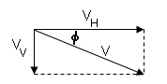
find v_{v} 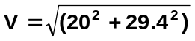
v_{v}² = u_{v}² + 2gs
= 0 + (2 x -9.8 x -44.1) V = 35.6 ms⁻¹ [1 mark]
= 864.36 φ = tan⁻¹ (29.4 ÷ 20)
v_{v} = 29.4 ms⁻¹ [1 mark] = 55.8⁰ [1 mark]
u_{v} = 0
u_{H} = 20.0 ms⁻¹ V = 35.6 ms⁻¹ 55.8⁰ below the horizontal
s_{v} = -44.1 m [1 mark]
g = -9.8 ms⁻²

- Two boys are playing a game with marbles on a 1.20 m high table. The aim is to hit marble A (mass of 0.210 kg) with marble B (mass of 0.160 kg) with enough force so that marble A rolls off the table and into a cup below. The cup is placed 0.664 m from the edge of the table. If one boy shoots marble B at marble A with a velocity of 1.75 ms⁻¹, will the marble land in the cup? (Assume no friction when the marbles roll). (3 marks)

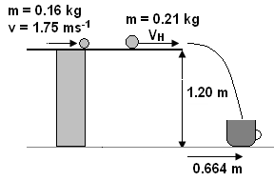
To find V_{H} use conservation of momentum

Σp_{i} = Σp_{f}
m_{v}v₁ = m₂v₂
0.16 x 1.75 = 0.21 x v_{v}
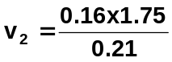
v₂ = 1.3333 ms⁻¹ [1 mark]

u_{H} = 1.3333 ms⁻¹ s_{v} = u_{v}t + ½ gt²
u_{v} = 0 ms⁻¹ -1.20 = 0 – 4.9t²
g = -9.8 ms⁻¹ t = 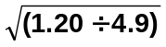
s_{v} = -1.20 m t = 0.49487 s [1 mark]

s_{H} = u_{H} x t
= 1.3333 x 0.49487
s_{H} = 0.660 m
Yes, the marble will land in the cup
as it will travel 0.66 m and the cup
is 0.664 m away. [1 mark]

- The stunt car shown in the diagram below is at the highest point of its flight as it jumps from one ramp to another. If the effect of air resistance is taken into account, which of the letters shown best represents the direction of the net force acting on the stunt car (circle answer)? (No explanation necessary.)

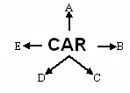

Answer: ___ D ___ [1 mark]

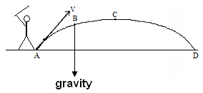

- Alistair is playing golf. He hits the ball
into the air as shown. (Assume no air resistance.)

a. What name is given to the shape of this path?
Parabola [1 mark]
- Draw and label the force/s acting on the ball at
point B. (2 mark) arrow [1 mark]
gravity [1 mark]

- In PE, Emma and Cynthia are throwing a ball to each other. Emma throws the ball at an angle of 30.0⁰ to the horizontal and it reaches a maximum height of 1.60 m above its release point. With what initial velocity did Emma throw the ball? (3 marks)
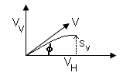
to top of throw
v_{v}² = u_{v}² + 2gs
0 = u_{v}² + (2 x -9.8 x 1.6)
0 = u_{v}² – 31.36
u_{v} = 5.60 ms⁻¹ up [2 marks]

V_{v} = u_{v} = V sin 30 u_{v} = V sin 30
v_{v} top = 0 5.6 = V sin 30
g = -9.8 ms⁻² V = 5.6 ÷ sin 30
s_{v} = 1.60 m V = 11.2 ms⁻¹ [1 mark]

- Brie is involved in competition diving. Her centre of mass is 10.0 m above the water and in a perfect dive, she leaves the high diving board with an initial velocity of 8.40 ms⁻¹ at an angle of 85.0⁰ to the horizontal. If the board projects 1.30 m from the edge of the swimming pool, how far from the edge of the pool does Brie enter the water? (4 marks)
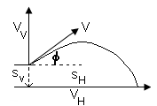
easiest with solver s_{H} = u_{H} x t
-10 = 8.368t – 4.9t² = 0.7321 x 2.518
t = 2.518 s s_{H} = 1.84 m

otherwise:

V_{v} = u_{v} = 8.4 sin 85  = 8.368 ms⁻¹  V_{H} = u_{H} = 8.4 cos 85  = 0.7321 ms⁻¹  s_{v} = -10.0 m  g = -9.8 ms⁻²  [1 mark values] | v_{v}² = u_{v}² + 2gs  = 8.368² + (2 x -9.8 x -10)  = 266.023  v_{v} = 16.31 ms⁻¹ down [1 mark]  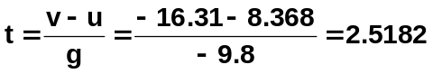s [1 mark]  s_{H} = u_{H} x t  = 0.7321 x 2.518  s_{H} = 1.84 m [1 mark]

- Marelize is a champion archer. At one competition she shoots an arrow at 32.5 ms⁻¹ at an angle of 40.0⁰ to the horizontal. She hits the centre of the target which is at the same height the arrow was released. How far away was the target? (2 marks)

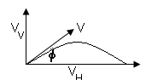
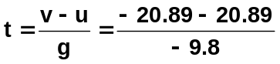
t = 4.2633 s

V_{v} = u_{v} = 32.5 sin 40 = 20.89 ms⁻¹ s_{H} = v_{H} x t
v_{v} = -20.89 ms⁻¹ = 24.90 x 4.2633
V_{H} = u_{H} = 32.5 cos 40 = 24.90 ms⁻¹ s_{H} = 106 m
g = -9.8 ms⁻²

- You have a potato gun set up on a 50.0 m tall building. You fire the potato across the road at another even taller building which is 35.0 m away to land on its roof 74.8 m above the ground. When the potato hits the roof it is moving horizontally.

- Calculate the vertical component of the initial velocity of the potato. (2 marks)
b. Calculate the time taken for the potato to reach the ledge. (2 marks)
c. Calculate the horizontal component of the initial velocity of the potato. (2 marks)
d. Calculate the angle at which the potato was initially thrown. (1 marks)

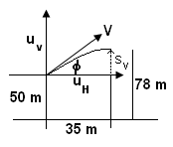
a. v_{v}² = u_{v}² + 2gs_{v}
0 = u_{v}² + (2 x -9.8 x 35)
-486.08 = u_{v}²
u_{v} = 22.047 u_{v} = 22.0 ms⁻¹ upwards

b. 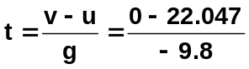

t = 2.2497 t = 2.25 s
u_{v} = V sin φ
v_{v} top = 0 c. 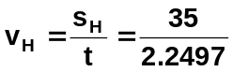
u_{H} = V cos φ = 15.5576 v_{H} = 15.6 ms⁻¹
s_{v} = 78 – 50 = 24.8 m
s_{H} = 35.0 m
g = -9.8 ms⁻² d. φ = tan⁻¹ (22 ÷ 15.5576)
= 54.7⁰

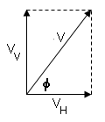
so potato is fired at 54.7⁰ above horizontal.

- A trapeze artist swings on a rope from a platform. He leaves the platform without any horizontal velocity and lets go of the rope when he reaches B, the lowest point in his swing. The rope is 3.20 m long, initially inclined at 40.0⁰. Point B is 2.45 m directly above C. A safety net is located at D. You can assume the net to be horizontal at point D. the path of the trapeze artist’s centre of mass is shown from the platform to D.
- Calculate the velocity of the trapeze artist at point B.
- How long will it take him to fall from B to D.
- How far from C should the safety net be placed (i.e. find the distance CD)

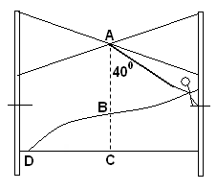
a. Velocity at B

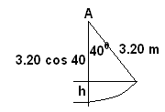
Firstly calculate drop
= 3.20 – (3.20 cos 40)
= 3.20 – 2.4513
= 0.7487 m

now this drop is his loss in potential energy and he gains kinetic energy so

E_{p} lost = E_{k} gained
mgh = ½ mv²
gh = ½ v²
  - x 0.7487 = 0.5 x v²
v² = 14.6745
v = 3.83 ms⁻¹

b. time to fall from B to D (NB: as everything is downwards leave as positive)
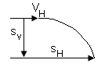
s_{v} = 2.45 m s_{v} = u_{v}t + ½ gt²
u_{v} = 0 ms⁻¹ 2.45 = 0 + 4.9t²
g = 9.8 ms⁻¹ 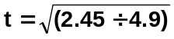
t = 0.707 s

c. Distance CD

distance CD is the horizontal displacement, s_{H}

u_{H} = 3.83 ms⁻¹ s_{H} = u_{H} x t
t = 0.707 s = 3.83 x 0.707
s_{H} = 2.71 m

- A machine is to be designed to fire tennis balls from ground level to a point 10.0 m away from the machine, and 1.50 m above ground level as shown. The angle of projection will be 25.0⁰. Calculate the speed with which the balls must be projected. (5 marks)

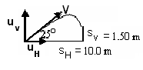
Always advisable to redraw diagrams
showing all information given.

This question has two unknowns so you need
to use simultaneous equations to solve.

u_{v} = V sin 25
u_{H} = V cos 25
g = -9.8 ms⁻¹
s_{v} = 1.5 m
s_{H} = 10 m

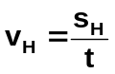Horizontal Vertical

s_{v} = u_{v}t + ½ gt²
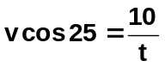
1.5 = (V sin 25)t + )-4.9t² equation 2
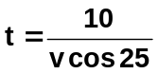

equation (1) [2 marks]

substitute equation (1) into equation (2)

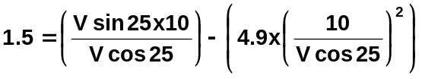
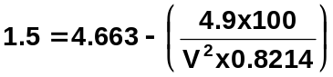

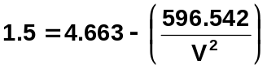
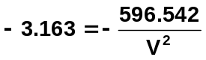
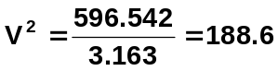
V = 13.733 [2 marks]

V = 13.7 ms⁻¹ at an upward angle of 25⁰ to the horizontal
[1 mark]

